Experiment no 5-

Write a shell script and C program to perform the following string operations: a) To extract a substring from a given string.

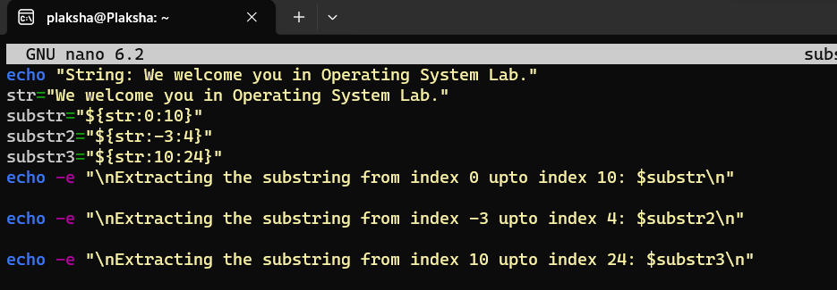

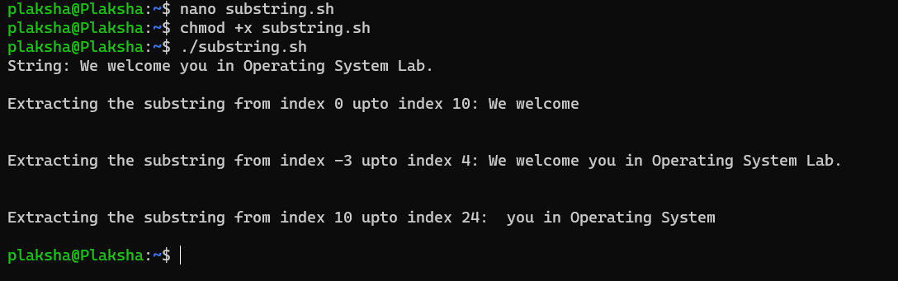

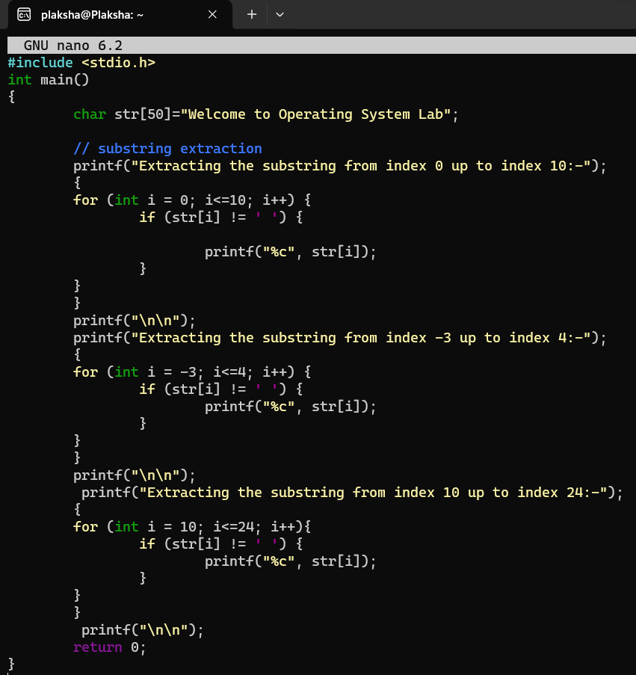

b) To find the length of a given string.

